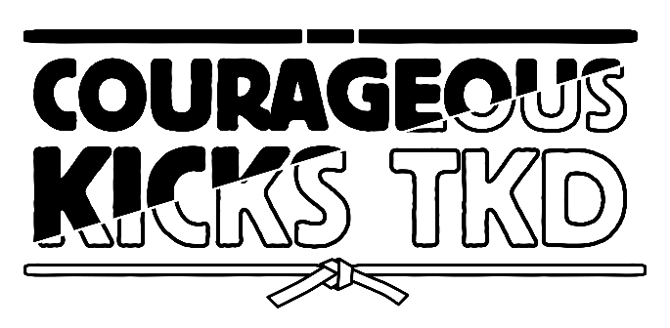

Welcome to Courageous Kicks Taekwondo! We consider our students and their family’s part of our family. This packet helps explain our school culture as well as customs and courtesies of taekwondo.
We do not want to surprise you with any cost.
All Prices
Starting Prices:
Starting Uniform | $50
Monthly Tuition  Unlimited Membership | $119 (20% discount for additional family members)
Monthly Tuition for Chung Do Kids | $65 (two days a week)
Yellow belt testing prices:
First promotion (after 3 months) | $35
USCDKA membership | $32
Gold belt testing
Promotion | $35
Portfolio | $45
Other Cost:
10 promotions (including yellow and gold) | $35 each
Sparring gear | $150
Tournaments not required but is a great way for students to grow as martial artist | Range from $45-$120
Black belt testing | $150
Instructor degree for testing | $150
Each degree black belt adds $100 that goes to the national association and is part of their cost to be nationally certified. This certification is very important to a martial artist.

Our Ranking:
When students sign up for class, they receive a white belt. In order to graduate to the next rank students, need to know the requirements for their new belt and reach the attendance requirements. Every time a student attends class they will pull their card to receive a star. It takes three months to be eligible to test for a beginner rank (24 stars). It takes four months to be eligible to test for intermediate and advanced ranks (32 stars):

Beginner Ranks:
White
Yellow
Gold
Orange
Intermediate Ranks:
Green
Purple
Blue
Advanced Ranks:
Red
Brown
1st Gup (Brown with a black stripe)
Black Belt Ranks:
Black Belt
Black Belt goes up to nine degrees

Customs and Courtesies
Taekwondo is full of customs and courtesies that teach students respect, many of which are influenced by Korean culture.
- When entering or leaving the school, students should bow as a sign of respect and remove their shoes and socks for safety, balance, and cleanliness. Parents should remove their shoes if they are on the mat to keep it clean.
- Students should always say "yes, ma'am/sir" or "no, ma'am/sir" to black belts and instructors and should be respectful in speech and action.

Uniform
Scan for belt tying instructions.
Your instructors love
helping you learn so
always feel free to ask.
During daily classes, students should wear:
- White pants
- Courageous Kicks/tournament shirt
- Ranking belt

For testing, tournaments, and special events, students should wear:
- White pants
- Uniform top (Doebalk)
- Belt
- Shirt that matches their belt. If a student is testing for a new rank, they should wear their current rank shirt under their uniform.
- Belts should not touch the ground except when being worn, out of respect.

Promotion and Graduation:

When a student is eligible to test you will receive a link for registration. This link will specify the date and time of the testing. Students need to arrive T testing ten minutes early and need to stay the entire testing. Testing usually take two hours. Students will graduate (receive their new rank) at their next traditional class.
Promotion requirements are on our website at: www.Couragoeuskickstkd.com/promotions

U.S Chung Do Kwan Association (National Association)
Our National Association, the U.S Chung Do Kwan Association, is led by Sr. Grandmaster Brenda J. Sell, the highest ranked non-Korean woman in the world. The association was founded by her late husband Sr. Grandmaster Edward B. Sell, and hosts seminars, conferences, and tournaments to improve instructors and students. Certification for promotions is also provided by the association, making each ranking nationally recognized. When students become yellow belts, they become members of the association.
- Gold belt students are required to purchase a portfolio, which allows them to set goals and track their progress.
- For each testing, students must write a paragraph or draw a picture based on the prompt assigned to their belt. These prompts can be found on the promotion page of the website.
Tournaments:
Tournaments are an important part of taekwondo training, helping students:
- Build confidence
- Improve their understanding of the sport
- Set new goals
- Improve through competition
- Students are required to compete in two tournaments before becoming black belts.
General Tournament Schedule:
- February-Fast Kicks Tournament in Seffner
- April-State in Bartow
- July-Nationals in Orlando
- September-Teal Tournament in Titusville (Courageous Kicks host this tournament and all the proceeds go to Ovarian Cancer Research. Please make every effort to attend this tournament).
- October or November- Brenda J. Sell Classic in Lakeland
- December- Extravaganza in Bartow
Our tournament season ends after Nationals in July
Students are required to compete in two tournaments before they are a black belt.
Tournaments help build confidence, an better understanding of the sport, helps inspire them to set new goals, and it helps them improve themselves through competition.

